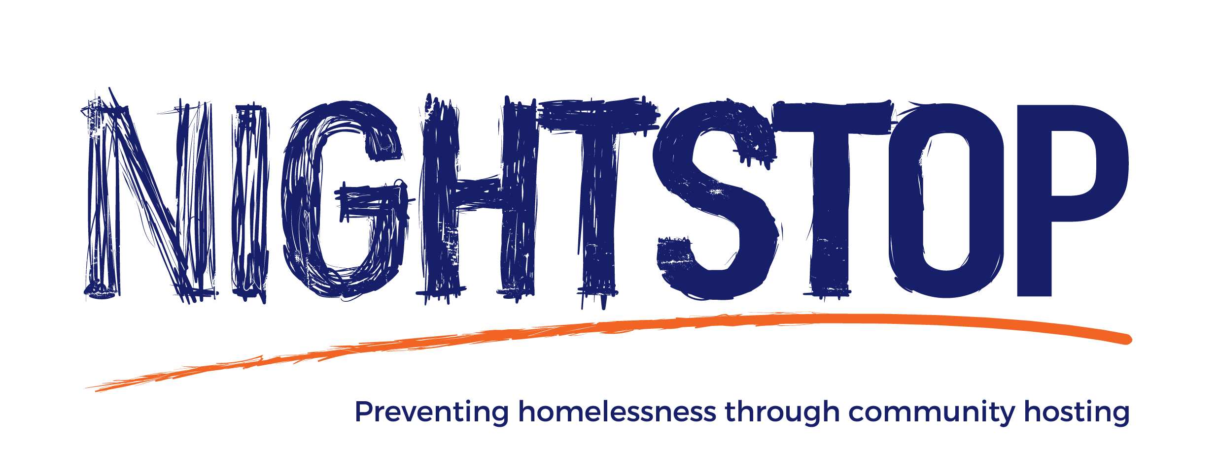

Nightstop frequently asked questions

nightstop frequently asked questions

Who uses Nightstop?

75% of guests who used Nightstop in 2017 became homeless because something went wrong at home as a result of family or relationship breakdown. Yet, many of the guests on Nightstop are committed to moving forward positively with their lives. 34% of Nightstop guests were in education, employment or training at the time of referral.

How does it work?
- A young person who is experiencing homelessness is referred to the Nightstop service, either directly through a self-referral or by Nightstop partners such as schools, colleges, local charities and social care.

- The Nightstop service talks to the young person about their personal situation and conducts a risk assessment, including references, to see whether they are suitable to be placed on Nightstop.

- If the guest is deemed low-risk then a trained volunteer host is given information about the guest and asked if they want to volunteer that evening.

- If a host confirms their availability then the Nightstop service will talk to the guest about what they should expect from the placement, the host’s home rules and how they will get there. If a driver or chaperone is also available then they can make sure that the guest arrives safely at the host’s home.

- The guest arrives at an agreed time and is offered an evening meal, a shower or bath, use of the washing machine and a clean, private room.

- The Nightstop service will contact the guest and host that evening and in the morning to check that everything is OK.

- The guest then leaves the next morning at an agreed time having had breakfast and with a packed lunch.

- Either the Nightstop service or Nightstop partner agencies work with the guest to find long-term accommodation.

Is it safe?

Our number one priority is to ensure that volunteers and guests are safe and comfortable. The Nightstop team conducts thorough risk assessments for all guests. We ask questions about their homelessness situation and whether they have a criminal history or any mental/physical health needs. We also look more generally into their personal character and behaviour. We work closely with various agencies that refer guests to Nightstop and seek references, speaking to a professional who has known the guest and can give informed answers to the risk assessment.

What would I be expected to do as a host?

You don’t need any specialist experience or qualifications to become a Nightstop host. All you need is a spare room in your home and a welcoming and supportive outlook. You’ll provide young people in need with a listening ear, washing facilities and an evening meal, breakfast and a packed lunch.

How often would I be expected to host?

Volunteers can host as often as they want. Some volunteers host a few nights a week and other volunteers host a couple of times a month. The Nightstop service asks its hosts which nights they will be available and then checks to make sure the host is still free before making the arrangements for that evening.

What would I be expected to do as a driver or chaperone?

Nightstop services rely on volunteer drivers and chaperones to take young people to hosts’ homes, either in their car or on public transport. You’ll meet the guest at a pre-arranged place then, once you arrive safely, you’ll introduce them to their hosts.

Do I get training?

Nightstop will provide you with thorough training before you receive your first guest. The training gives you an introduction to homelessness in the UK, and lets you practice the skills you need to become a host. By the end of the training you’ll understand all of the processes that Nightstop go through before a guest arrives at a placement, everything you need to know to keep yourself and the guest safe and top tips to make guests feel welcome in your home. We also provide ongoing training once you’re in the role to further enhance your skills and understanding.

What kind of support do volunteers get?

You’ll be given regular catch up meetings with our staff to see how you are finding volunteering with Nightstop. We also host social events where you can get the chance to meet other volunteers and share ideas.
You’ll be supported throughout the process and Nightstop staff will always be on hand. You’ll receive a check-in call in the evening of the placement and in the morning to make sure that everything went OK, and a Nightstop staff member will be available 24/7 in case of emergencies.

Can the Nightstop guest go out in the evening?

After arriving at the host’s house, a guest is able to go out again in the evening if they so wish. The time that the guest should return by should be agreed with the host and the guest.

Are visitors allowed whilst hosting?

We ask hosts not to have visitors calling at their home when they are due to have a guest staying over. This is because we always complete a vetting process for any adults the guest will be coming into contact with. The presence of visitors might also make the guest feel uncomfortable.

What happens over weekends?

Nightstop only takes a few referrals over weekends, so most placements will be made for the entire weekend, from Friday evening until Monday morning.

Most of the same rules will apply i.e. the guest is not allowed to be in your house while you are not in. If you go out, they will have to go out too. However, if you are staying in it is up to you whether you want to ask them to leave in the morning and return before dinner in the evening, or stay in too. We usually find it helpful if you let us know on Friday what you plan to do that weekend so that we tell the guest in advance.

Can I use my DBS check from another organisation?

No. Unfortunately the system requires Nightstop Milton Keynes to have their own DBS check for all staff and volunteers. This will include any you have recently had from another organisation, we can not accept it.

Will I get expenses?

All Nightstop volunteers can claim out of pocket expenses.

What happens to the guest after they leave in the morning?

The guest will leave at an agreed time in the morning and, if they require another night on Nightstop, return to a host’s home at an agreed time. How long the guest uses Nightstop for varies on a case by case basis, but is usually between 3 days to 3 weeks and may be with the same host or with different hosts.

What a guest does during the day depends on their personal circumstances: They might have a job or be enrolled in school or college; they might work with a partner offering mental health support or support with education or training opportunities; or they might meet somebody from the Nightstop team or another organisation to help them find long term accommodation. Long term accommodation could include Supported Lodgings, private renting or moving back with family members after mediation work has taken place.

